  PJT03025.R4B.SAP.FS.POST.Missing.Demand | 



REVIEWER(S)
Name | Title | Department | Reviewed (date/time)
Manoj Ajgaonkar | SAP QA Advisor | Smart Energy Program | <Date / Time>
Scott Tingle | AMI Program Lead | BTS | <Date / Time>
Chaitanya Kodela | Solution Architect | BTS SDM-Application Platform Svcs | <Date / Time>
Nitish Walia | Solution Architect, Capgemini | Smart Energy Program | <Date / Time>
Jack Hobbick | PROG TESTING SOLUTIONS MG | AMI Opers & Impl | <Date / Time>
Amit Jadli | Test Lead, Capgemini | Smart Energy Program | <Date / Time>
Jessica Scott | Audit Controls, Deloitte | Smart Energy Program | <Date / Time>
Clark Oeler | Audit Controls, Deloitte | Smart Energy Program | <Date / Time>
Harikrishnan Bhanu | Technical Consultant, Itron | Smart Energy Program | <Date / Time>
Manuel Beltrandelrio | EMMA Lead | BTS | <Date / Time>

APPROVER(S)
Name | Title | Department | Approval (date/time)
Loknath Sri | SAP lead, CMS Energy | Smart Energy Program | <Date / Time>
Ramesh Swarna | SAP Lead, Capgemini | Smart Energy Program | <Date / Time>
Susana V Ward | BTS TECH TEAM LD/ PROJ MGR | BTS SDM | <Date / Time>
Chad Conrad | BTS PROJECT MGR II | BTS SDM | <Date / Time>
 |  |  | <Date / Time>

CONTRIBUTORS
Name | Organization | Area of Contribution
Dominic Pappaly | Capgemini | Billing
Rajesh Pandey | Capgemini | Billing
Mary Jane Afable | SAP | Billing

VERSION HISTORY
Version | Date | Author(s) | Revision Notes
0.1 | 10/30/14 | Mary Jane Afable | Initial Version

Table of Contents

REVIEWER(S) 2
APPROVER(S) 2
1 OBJECT REQUIREMENT SUMMARY 5
1.1 Object Information and Attributes 5
1.2 Requirements Summary and Business Driver 6
1.3 Current Functionality 6
1.4 Required Functionality 7
1.5 Assumptions 7
1.6 Project / Development Constraints 7
1.7 Performance Criteria 7
2 DETAILED SPECIFICATIONS 8
2.1 RICEFW Type Specific Information – BADI Enhancement 8
2.2 RICEFW Type Specific Information – Billing Variant Enhancement 11
3 ADDITIONAL INFORMATION 12
3.1 Unit Test Plan 12
3.2 Information Security 13
3.3 Redwood 13
4 Questions / Issues / Risks 13
4.1 Questions/Issues/Risks 13

OBJECT REQUIREMENT SUMMARY

Object Information and Attributes

The following is current information about this object and document:
Object ID | BL_ENH_POST_002
Title | Missing or Invalid Demand Value
Team Which Owns the Object | Customer Billing
System Version | ECC 6.0
Development Type | Enhancement
Priority | M
Estimated Complexity | M(edium)
Link to Process Flow | Refer to System BPD for Post Cutover to Interval Billing

Requirements Summary and Business Driver

As a part of the initiative, the calculation of the max demand billing determinant will be based on interval values in the external MDM system and performed by the MDM system. In case the max demand value cannot be calculated (missing billing determinant), or the calculated value failed validation (invalid billing determinant), then an EMMA case needs to be triggered for further investigation.

Ref. | Gap Description
BL_ENH_POST_002 | Variant Program for Missing Demand  If the max demand from the MDM system has no value then we need to raise a billing error message specifying Max Demand not received. This would be accomplished through a custom variant program modeled on the variant program ISU_ZUTILI99

Note that in addition to the variant program which will take care of the invalid billing determinant, a BADI enhancement will also be required for the missing billing determinant.

Alternatives to Object

For the missing demand, users would be able to see the billing issue in the ABE Exception queue in MDM.

Impact of Implementation
The new billing variant will allow SAP billing to issue a billing error application log message if the billing determinant received is invalid. The actual validation will be controlled by the billing rates. The billing error application log message will then be used to trigger an EMMA case.

The BADI enhancement will trigger an application log message if the billing determinant is missing. The application log message will then be used to trigger an EMMA case.

Impact of No Implementation

Not applicable.

Current Functionality

Not applicable

Required Functionality
This functional specification will detail the development required to trigger EMMA case creation for missing and invalid billing determinant:

- Invalid billing determinant: Create a custom variant program to terminate billing and issue a billing application log message.

- Missing billing determinant: Implement the BADI ISU_SE_TSCALCCRTBLKRCO_ASYN available for the standard MDM response to a Max Demand Billing Determinant request (Time Series Calc request) to create an application log warning message for every determinant received from the IEE system which has a severity code of 3.

Assumptions

The billing variant will be used to raise a billing error message only. All validation will occur in the rate steps.

Project / Development Constraints

The MDM inbound web service interface Change Based On Utilities Time Series Calculation Creation Confirmation will have to be configured.

The billing variant will need to be configured.

Performance Criteria

This enhancement will be called every time the MDM responds to a Time series request from SAP

Performance Requirements for Enhancements
Average Frequency: | 1000 | 1000 inbound responses on average per batch day
Frequency per Peak: | 2000
Availability: | 24/7
Expected Average Response Time: | 15 mins
Expected Peak Response Time: | 30 mins

DETAILED SPECIFICATIONS

RICEFW Type Specific Information – BADI Enhancement

Enhancement Details (if applicable)
SAP Transaction Code | N/A
Menu Path | N/A
User Exit Name | ISU_SE_TSCALCCRTBLKRCO_ASYN

Enhancement Requirements
Number | Description of Requirement
 | Implement BADI - ISU_SE_TSCALCCRTBLKRCO_ASYN
 | Create new system message in message class ZBILL and message no 225.

Processing Logic

BPEM Case Creation from the BADI

Implement the BADI ISU_SE_TSCALCCRTBLKRCO_ASYN for the Inbound response for a Time Series Request (UtilitiesTimeSeriesCalculationERPBulkCreateConfirmation_In). The response has a confirmation log with a severity code, which indicates if the billing determinant cannot be derived. This is in method INBOUND_PROCESSING, parameter XY_APPLDATA and structure PRX_GDT_LOG. Structure PRX_GDT_LOG contains line item PRX_GDT_LOG_ITEM which contains the field SEVERITY_CODE.

Figure 1: Method INBOUND_PROCESSING
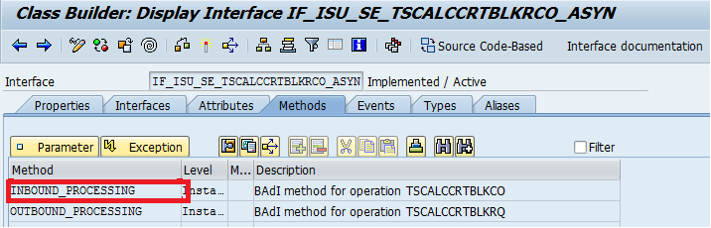

Figure 2: Method parameters
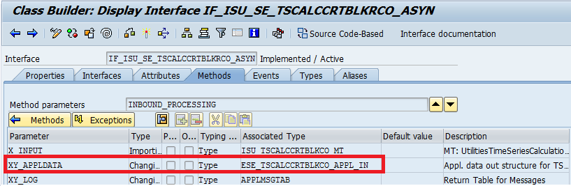

Figure 3: Structure for parameter XY_APPLDATA
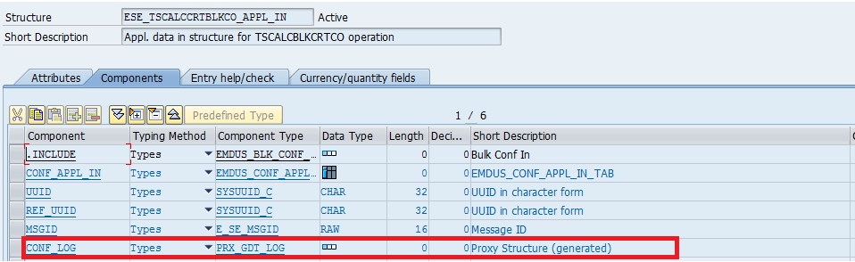

Figure 4: Structure containing SEVERITY_CODE field
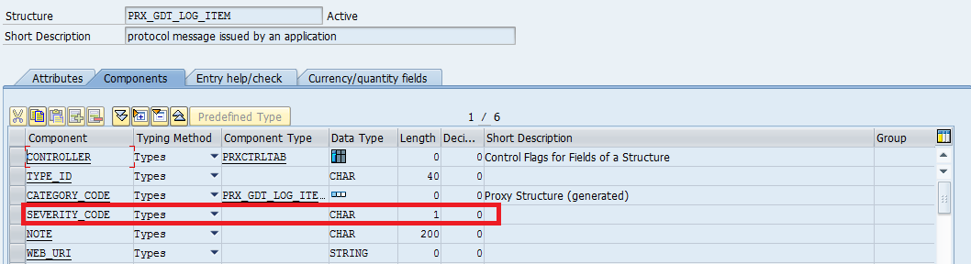

Figure 5: Sample XML response
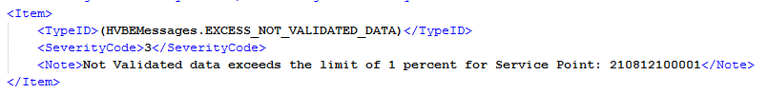
Figure 6: Sample XML file

If the severity code = 3, then we would need to create an application log warning message. This message will be used to create the EMMA case.

The system message written to the application log would be ‘Max Demand &1 for Installation &2 and Scheduled Billing date &3. Create the message in Message Class ZBILL and use message number 225.

The message log parameters would have the following values:
&1 = ‘missing’
&2 = installation number
&3 = scheduled billing date

The business process area of the BPEM case would be EBI00001 and primary object installation. An EMMA case category would be configured to be created for system message id ZBILL and the message number 225. The installation number and scheduled billing date can be derived from the MDUS Request Data Table (EMDUSDRQHEAD) based on the MDUS Request Id in the response.

RICEFW Type Specific Information – Billing Variant Enhancement

Enhancement Details (if applicable)
SAP Transaction Code | SE37
Menu Path | N/A
User Exit Name

Enhancement Requirements
Number | Description of Requirement
 | Create a function module ISU_ZUTIL99O to terminate billing and raise an error message.
 | When creating the new FM, reference FM = ISU_ZUTIL99L and use function group = Z_CS_RATES_TERMINATE
 | Use the same message as the BADI enhancement in 2.1

Processing Logic

The billing rates will perform the validation and call the variant. The validations are:

Billing determinant demand value is negative
- Billing determinant demand value is greater than 999

BPEM Case Creation from the BADI

Create function module ISU_ZUTIL99O based on existing function module ISU_ZUTIL99L. Update the code to raise message class ZBILL and message no 225.

The system message written to the application log would be ‘Max Demand &1 for Installation &2 and Scheduled Billing Date &3’.

The message log parameters would have the following values:
&1 = ‘invalid’
&2 = XY_OBJ-TRIG-ETRG-ANLAGE
&3 = XY_OBJ-TRIG-ETRG-ABRDATS

An EMMA case category would be configured using system message id ZBILL and message number 225.

ADDITIONAL INFORMATION

Unit Test Plan

Information Security

Security Roles (Profiles and Authorizations)
Not applicable

Security Requirements for Enhancements
Security Type | Role | Access Allowed
Screen Level Security | N/A | <read, read/update>
Field Level Security | N/A | <List restrictions on the fields on the form that individuals with this role can either see. The fields like SSN number, Credit Card number, etc that has sensitive information need to be listed with the kind of access for query, display and print.>
Button Security | N/A | <Any restrictions on the buttons that someone with this role can either see and/or invoke>
Data Security | N/A | <Any restrictions on the data that someone with this role can either see and/or update>

Redwood
Not applicable

Questions / Issues / Risks
Not applicable.

Questions/Issues/Risks
Asked By | Question/Issue/Risks | Resolution | Resolution Date

